YEAR RECEPTION / PSHE & Understanding of the World / KNOWLEDGE ORGANISER
Teach children how they should live and they will remember it all their lives Proverbs 22:6
 | 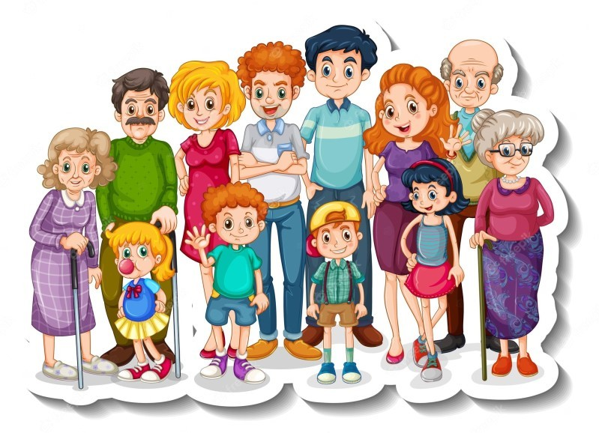
  Subject Specific Vocabulary
  family | A group of people who are related to each other and usually live together
  siblings | Brothers and sisters
  happy | A feeling of joy
  sad | Feeling unhappy
  worried | Feeling unsettled and uneasy
  scared | Feeling unsure and worried
  excited | Feeling happy and keen to so something
  nervous | Feeling worried about something
  shocked | Feeling surprised
  unique | Being one of a kind and different to everyone else
  In this unit we will learn about:
  - Working as part of a group or class while taking turns.
  - Understanding and following rules.
  - People who are important to us.
  - Similarities and differences between ourselves and others.
Key Facts |  | Exciting Books
Key Facts |  | 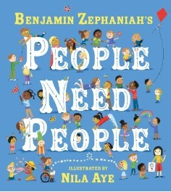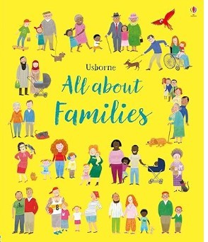  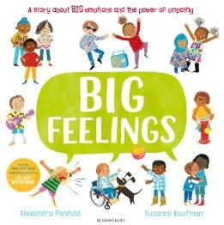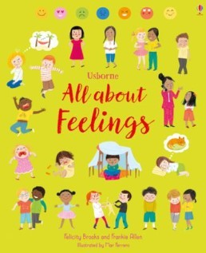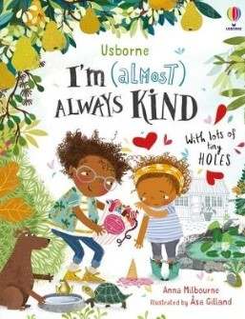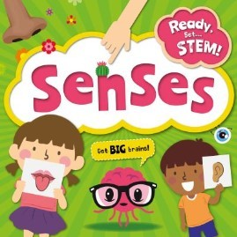
A family is a group of people are related to one another. Every family is different and some families are multi-cultural.
Friends are people who like spending time together.
Everyone is unique and every family is different.
We have a range of emotions that we can experience at different times.
The 5 senses are taste, hearing, sight, smell and touch.

  Emotions
  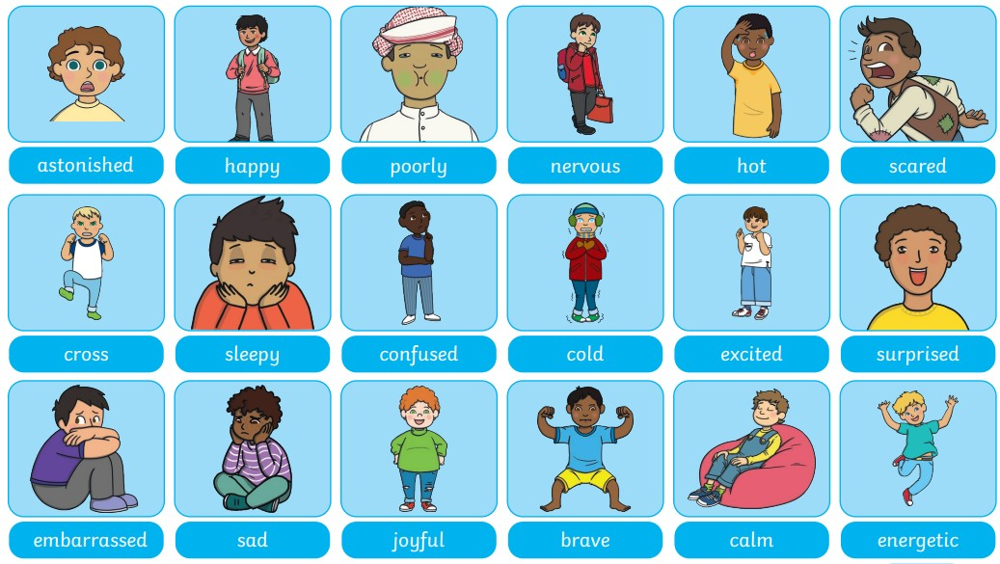
  Websites
  https://www.bbc.co.uk/bitesize/topics/zwbr8p3/articles/zcgsb7h https://www.bbc.co.uk/bitesize/topics/zwbr8p3/articles/zq74wsg https://www.bbc.co.uk/bitesize/topics/zwbr8p3/articles/z4cyrmn
  https://classroom.thenational.academy/subjects-by-key-stage/early-years-foundation-stage/subjects/ understanding-the-world
Making Friends
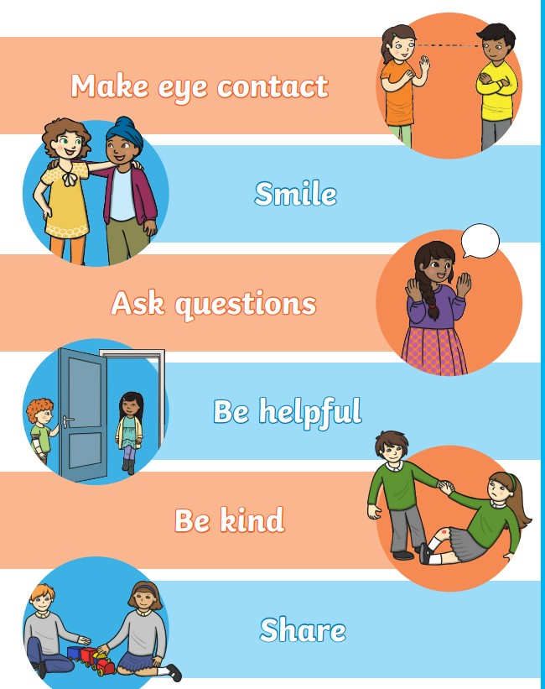

Family Word Mat
